Ultimate Youth Worker
Genograms
An Introduction

Aaron Garth
01-Sep-16

What is a Genogram?
A genogram is a picture of a person's family relationships and history. It goes beyond a traditional family tree allowing the creators to visualize patterns and psychological factors that affect relationships.
Genograms were first developed and popularized in clinical settings by Monica McGoldrick and Randy Gerson through the publication of a book titled Genograms: Assessment and Intervention in 1985.
Genograms are now used by various groups of people in a variety of fields such as medicine, psychology, social work, genetic research, education, and youth work to name but a few.
Some practitioners in personal and family therapy use genograms for personal records and/or to explain family dynamics to the client.

Why would I use a genograms?
A genograms is a really useful tool to for helping us to understand the key people and relationships in a clients life. It can also help us to see patterns within those relationships and generational patterns which are affecting our client. Because of the pictorial nature of a genograms it easily shows issues and concerns that might not be spoken about usually in a non-threatening manner.
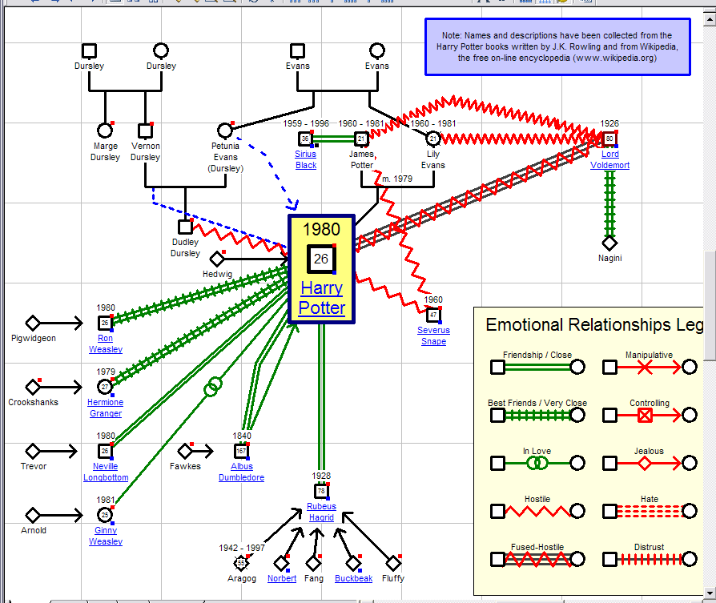
Genograms also help our clients to put a framework together that explains their circumstances. Many young people who are being abused struggle to speak about it, however showing them how to draw a genograms can lead them to drawing the abusive relationship which opens the dialogue. It can also help them see the concerns that we have as professionals for themselves. What a strengths based way of working through the issues.
Most of all genograms can change. They are a picture of what is happening now. When I work with families it is often when they are at the brink of all out war. Their genograms often look like a child got hold of the textas. Colour everywhere and squiggly lines as far as the eye can see. After a few months we revisit and there are a few less squiggly lines and a few less colours. It is then that I show them their old genograms and ask what has happened to make these changes happen? It is a great tool for showing the changes.

So what is in a genograms?
A genograms uses shapes to convey meaning. Squares are males, circles are females, triangles are pregnancy related. A cross through the shape means a death. Pets even get a jersey!
The shapes begin to tell us how many people and what sex they are. At this point we can add ages, names, Dates of birth and death. As much personal information as is needed.
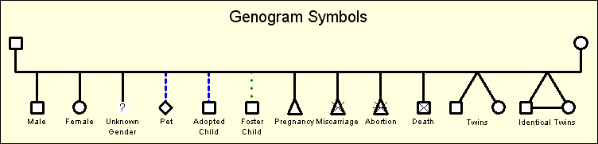

The next step is for us to add how the relationships are brought together. Otherwise we just have a bunch of shapes on a page.
Marriage is a solid line, divorce has two strokes through it. Dating is a dotted line etc
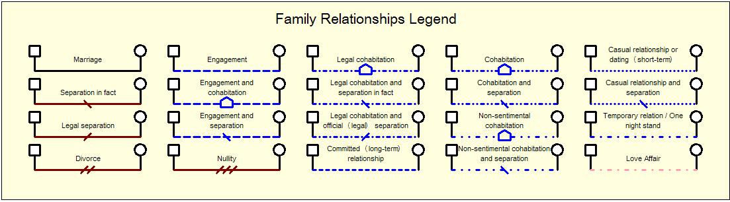

Finally we need to look at the emotional nature of the relationships. Are the relationships harmonious? Are there friendships or even best friends? Are they in love? Perhaps there is even hostility in the relationship. Is there violence, mistrust or even a family feud? Perhaps there is abuse, neglect or sexual abuse.
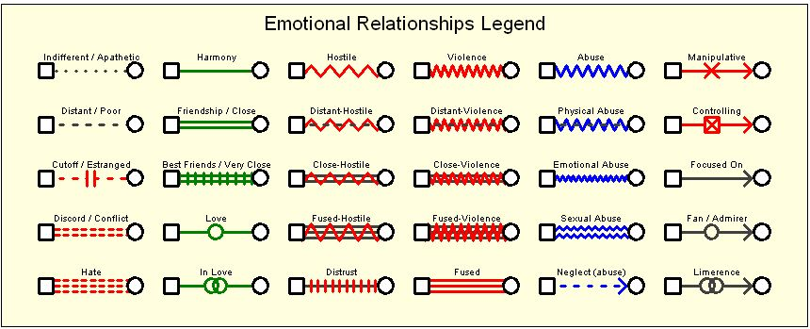
All of these little bits of information come together to paint a picture of how a persons family and relationships affect them. It shows the patterns and the history that make a person who they are. It can show situations, intergenerational concerns and family dynamics which create the environment for our clients to struggle. It can also be used as a therapeutic tool to address the struggles and bring about strength.

